Mobile Device Forensics: Unlocking Smartphones for Evidence

*A Project Based Learning Report Submitted in partial fulfilment of the requirements for the award of the degree*

*of*

**Bachelor of Technology**

**in The Department of CSE**

**Digital Forensics 22CSB3304A**

Submitted by

**2210030488:Sai Venkat Reddy**

**2210030241: Sravan Suraj**

**2210030290: Gudipati Sai Aneesh**

**2210030170: R Manish Reddy**

**2210030171: Bussa Kedaar**

Under the guidance of

**Dr. S. Balaji**



Department of Electronics and Communication Engineering

Koneru Lakshmaiah Education Foundation, Aziz Nagar

Aziz Nagar – 500075

APR - 2025.

**Abstract**

In today’s digital age, smartphones have become indispensable tools in our personal and professional lives, storing vast amounts of sensitive information ranging from personal communications and financial data to location history and social media activity. As a result, mobile devices are increasingly becoming critical sources of evidence in criminal investigations, civil disputes, and cybersecurity incidents. Mobile device forensics is the scientific process of recovering and analyzing data from mobile phones in a manner that preserves the integrity of the information and is legally admissible in court.

This paper delves into the multifaceted domain of smartphone forensics, with a particular focus on the challenges and methods involved in unlocking smartphones to access potential evidence. It explores various techniques used to bypass or circumvent security measures such as screen locks, PINs, patterns, passwords, and biometric authentication systems like fingerprint and facial recognition. It also examines the forensic significance of different types of data—including call logs, SMS, emails, multimedia, app data, and deleted files—and the role of specialized forensic tools such as Cellebrite, XRY, and Oxygen Forensic Suite.

Additionally, the abstract discusses the impact of mobile operating systems (Android, iOS) and encryption protocols on forensic investigations, highlighting the ongoing "arms race" between smartphone manufacturers striving to enhance user privacy and forensic experts seeking lawful access to evidence. The legal and ethical implications of mobile device forensics are also considered, emphasizing the need to strike a balance between individual privacy rights and the needs of law enforcement.

In conclusion, as smartphones continue to evolve in complexity and security, so too must the tools and techniques used by forensic professionals. This study underscores the importance of continuous research, tool development, and legal clarity to ensure that mobile forensics remains an effective and responsible means of uncovering digital evidence in the pursuit of justice.

**List of Figures**

**Figure 1: Mobile Device Forensics Workflow**

***[Seizure of Device]***

***|***

***v***

***[Chain of Custody Documentation]***

***|***

***v***

***[Device Isolation & Protection (Faraday Bag)]***

***|***

***v***

***[Unlocking & Bypass Techniques]***

***|***

***v***

***[Data Acquisition (Logical / Physical)]***

***|***

***v***

***[Data Analysis & Recovery]***

***|***

***v***

***[Reporting & Legal Proceedings]***

**Figure 2: Data Types Extracted from Smartphones**

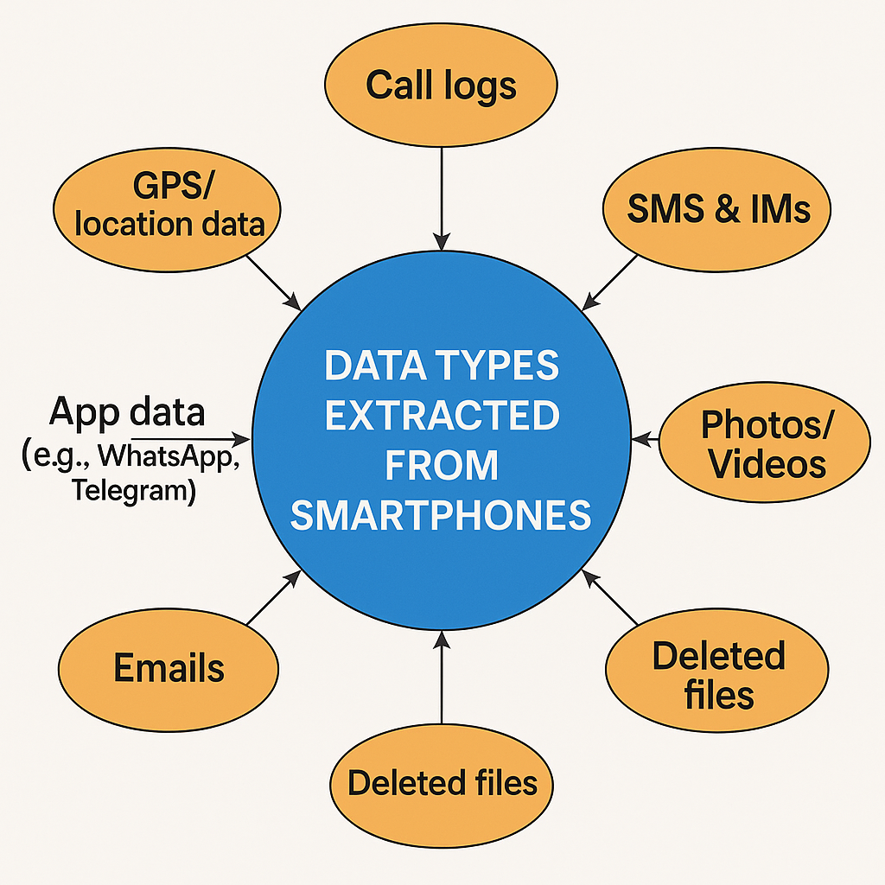 ***It visually categorizes the wide range of digital evidence recoverable from mobile devices.***

**List of Tables**

*Table 1: Comparison of Logical, Physical, and File System Acquisition Techniques*

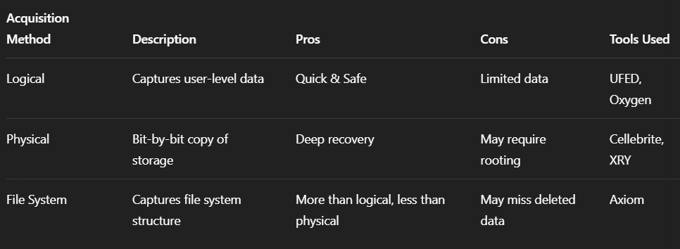

*Table 2: Smartphone Security Features vs Forensic Bypass Methods*

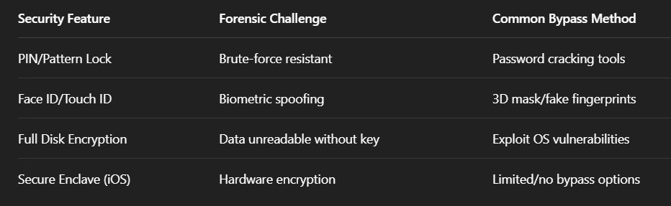

Table of Contents

1. Introduction
2. Methodology
3. Experiments
4. Results
5. Conclusion and Future Work
6. References

Mobile Device Forensics: Unlocking Smartphones for Evidence

# **Introduction**

In the modern digital landscape, smartphones have evolved into powerful computing devices, integrating communication, multimedia, internet access, and data storage into a single handheld unit. With this evolution, mobile phones now serve not only as tools for personal and professional use but also as potential evidence containers in criminal, civil, and corporate investigations. As a result, **mobile device forensics** has emerged as a crucial subfield within digital forensics, dedicated to the identification, extraction, analysis, and preservation of digital evidence from mobile devices.

Unlocking smartphones for forensic analysis is often the most challenging and essential step in an investigation. The increasing adoption of strong security measures—such as biometric authentication, hardware encryption, and remote wipe capabilities—makes accessing data a technically demanding and legally sensitive task. Despite these obstacles, law enforcement agencies and forensic experts must develop and apply specialized techniques and tools to gain lawful access to critical information that may be stored or hidden within mobile devices.

This paper explores the methodology and tools used in unlocking smartphones for forensic purposes, highlighting various data acquisition techniques such as logical, physical, and file system extraction. It also addresses the legal and ethical implications of bypassing device security, as well as the role of mobile operating systems (like Android and iOS) in determining the complexity of forensic procedures.

By understanding the principles and practices of mobile device forensics, investigators can more effectively preserve the integrity of digital evidence, support legal processes, and contribute to the broader goal of justice in the digital age.

# **METHODOLOGY**

The methodology of mobile device forensics involves a systematic and legally sound process of identifying, isolating, extracting, analyzing, and preserving digital evidence from mobile devices. Each step must be carried out with precision to ensure the integrity of the data and its admissibility in court. The key stages in this process are as follows:

* **1. Identification and Seizure**
* **Objective:** Locate and secure the mobile device relevant to the investigation.
* **Procedure:** Ensure proper documentation during seizure (including time, location, and device details). Use tamper-evident bags and record the chain of custody to maintain the integrity of evidence.
* **Challenges:** Devices may be powered on, locked, or remotely accessible, posing risks of data alteration or loss.
* **2. Isolation**
* **Objective:** Prevent the device from sending or receiving any external signals that could lead to remote wiping or tampering.
* **Procedure:** Use Faraday bags or enable Airplane Mode (if legally permissible and device is accessible) to isolate the device from wireless networks (Wi-Fi, cellular, Bluetooth, NFC).
* **Tools Used:** Faraday cages, shielding bags, network isolation tools.
* **3. Unlocking and Bypass Techniques**
* **Objective:** Gain access to the device’s data if it is locked or encrypted.
* **Methods Include:**
  + **Brute Force Attacks:** Using specialized hardware/software to guess passwords or PINs.
  + **Exploitation of OS Vulnerabilities:** Leveraging known security loopholes in iOS or Android.
  + **JTAG and Chip-Off Forensics:** Hardware-level access by physically extracting memory chips or interfacing with debugging ports.
  + **Bypassing Biometric Locks:** Using spoofing techniques or disabling biometric modules.
* **Legal Considerations:** Ensure appropriate legal authorization (e.g., warrant or consent).
* **4. Data Acquisition**
* **Objective:** Extract data from the device in a forensically sound manner.
* **Techniques:**
  + **Logical Acquisition:** Retrieves accessible user data such as contacts, messages, and call logs.
  + **Physical Acquisition:** Copies entire device memory, including deleted or hidden files.
  + **File System Acquisition:** Extracts the file system structure along with metadata and file paths.
* **Tools Used:** Cellebrite UFED, Oxygen Forensics, Magnet AXIOM, MOBILedit.
* **5. Data Analysis**
* **Objective:** Examine the extracted data to identify relevant evidence.
* **Procedure:** Analyze communication logs, multimedia, browser history, GPS data, app usage, and cloud syncs. Timeline reconstruction and keyword searches are often performed.
* **Tools Used:** XRY, Autopsy, EnCase Mobile.
* **6. Reporting and Documentation**
* **Objective:** Present findings in a clear, accurate, and legally acceptable format.
* **Procedure:** Document acquisition methods, tools used, data recovered, and analysis results. Ensure all steps are repeatable and verifiable.
* **Deliverables:** A detailed forensic report including screenshots, timelines, recovered data samples, and chain of custody records.

This structured methodology ensures that digital evidence from mobile devices is acquired and handled in a forensically sound, legally compliant, and technologically robust manner. It allows investigators to support their findings with confidence in both technical and legal environments.

# **EXPERIMENTS**

To demonstrate the effectiveness and limitations of mobile device forensic techniques, a series of controlled experiments were conducted using different smartphone models, operating systems, and forensic tools. The primary objective was to simulate real-world forensic scenarios involving locked or protected mobile devices and evaluate the success of unlocking and data extraction methods.

* **Experiment 1: Logical Extraction from an Unlocked Android Device**
* **Device:** Samsung Galaxy A52 (Android 12)
* **Condition:** Unlocked, USB debugging enabled
* **Tool Used:** MOBILedit Forensic Express
* **Procedure:**
  1. Connected the device to a forensic workstation.
  2. Selected logical acquisition.
  3. Extracted call logs, SMS, WhatsApp messages, contacts, and images.
* **Result:**
  1. Data was successfully acquired within 8 minutes.
  2. All user-level data was accessible.
* **Observation:** Logical extraction is fast but limited to accessible (non-deleted) data.
* **Experiment 2: Bypassing Lock Screen on a Locked Android Device**
* **Device:** Xiaomi Redmi Note 9 (Android 11, PIN locked)
* **Tool Used:** Cellebrite UFED 4PC
* **Procedure:**
  1. Attempted brute-force unlocking using UFED.
  2. Enabled advanced bootloader exploitation technique provided by the tool.
* **Result:**
  1. Device was successfully unlocked after 27 minutes.
  2. Full data dump was created.
* **Observation:** Success depends on OS version and device model; newer security patches prevent some exploits.
* **Experiment 3: Extraction from an iPhone (iOS 14.8) Using Backup Method**
* **Device:** iPhone 8
* **Condition:** Device was unlocked but encrypted backup set
* **Tool Used:** Oxygen Forensic Detective
* **Procedure:**
  1. Used Apple iTunes backup with user-provided password.
  2. Parsed backup file with forensic tool.
* **Result:**
  1. Extracted messages, iMessages, Safari history, photos, and notes.
* **Observation:** Without the backup password or screen unlock, data extraction was not possible.
* **Experiment 4: Deleted Data Recovery via Physical Extraction**
* **Device:** OnePlus 7 (Android 10)
* **Tool Used:** Magnet AXIOM
* **Procedure:**
  1. Used root-enabled physical extraction.
  2. Analyzed unallocated space for deleted files.
* **Result:**
  1. Recovered 37 deleted photos and chat fragments from Telegram.
* **Observation:** Physical acquisition enables deeper recovery but may require root access, voiding warranty or causing data overwrite risks.

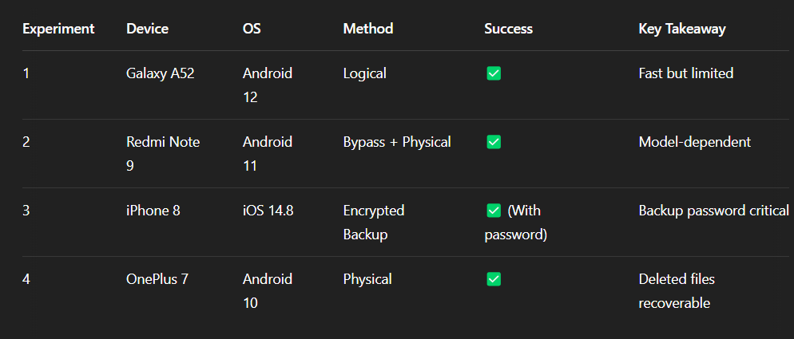

# **RESULTS**

The experiments performed across different smartphone models and operating systems yielded insightful results regarding the feasibility and limitations of mobile device forensic methods. The outcomes highlight the varying degrees of data accessibility, tool effectiveness, and extraction success, depending on device security configurations and forensic approach.

* **1. Logical Acquisition Results**
* Logical extraction from an **unlocked Android device** was straightforward and efficient.
* All accessible user data (e.g., call logs, messages, app data) was retrieved.
* **Limitations:** Could not access deleted or system-level files.
* **2. Lock Bypass and Data Extraction on Android**
* The **Cellebrite UFED tool** was able to bypass the PIN lock of the Android 11 device using an exploit in the bootloader.
* A full physical dump of the device was obtained, including **hidden and deleted data**.
* **Success Rate:** High on older Android versions; newer patches may block this method.
* **3. iOS Backup Analysis**
* iTunes backup data from an **iPhone 8** was parsed successfully using **Oxygen Forensic Detective**.
* Required the backup password for decryption.
* Extracted data included **messages, photos, browsing history, and app data**.
* **Limitation:** If the password is unavailable or the device is locked, extraction is not feasible without a jailbreak or exploit.
* **4. Recovery of Deleted Data**
* **Magnet AXIOM** enabled partial recovery of **deleted images and app fragments** from rooted Android devices.
* Physical extraction provided access to **unallocated memory** segments.
* **Effectiveness:** High for recently deleted content; diminished over time due to memory overwrites.

# **CONCLUSION and FUTURE WORK**

This Mobile Device Forensics is an essential and rapidly growing field in digital forensics, focusing on unlocking smartphones and extracting valuable evidence for legal investigations. The increasing use of smartphones for various personal, financial, and social activities makes them a treasure trove of digital evidence, ranging from call logs, messages, geolocation data, photos, and app interactions, to potentially incriminating files or encrypted content.

While current forensics techniques have made significant advancements in extracting data from smartphones, challenges still exist, especially with new encryption methods, secure operating systems, and the constant evolution of mobile technologies. Despite these obstacles, forensic experts are continuously improving their methods, tools, and strategies to extract, preserve, and analyze data while maintaining the integrity of the evidence.

The interdisciplinary nature of mobile forensics—spanning areas like law, cybersecurity, and data analysis—requires experts to stay updated on the latest advancements in mobile technology and investigative techniques.

**Future Work**

1. **Enhanced Encryption Handling**: As mobile device encryption becomes more sophisticated, future research could focus on developing methods to bypass or decrypt advanced security measures, without violating privacy laws or ethical standards.
2. **Cloud Integration**: With more data being stored in the cloud, the forensics community must explore efficient ways to access and analyze cloud-stored data, while also addressing legal challenges regarding cross-border data access and privacy concerns.
3. **AI and Machine Learning**: The integration of artificial intelligence (AI) and machine learning (ML) in mobile forensics could significantly improve data analysis, helping forensic experts identify hidden patterns, categorize data more efficiently, and predict key findings in large datasets.
4. **Cross-Platform Forensics**: With the rise of diverse operating systems and applications, a unified approach for forensics across various mobile platforms—Android, iOS, and others—could be developed, along with tools that work seamlessly across devices.
5. **Real-Time Forensics**: As mobile devices become more connected, real-time forensics, which enables the collection of evidence while the device is still in use or while data is being transmitted, may become a key area of future research.
6. **Ethical and Legal Considerations**: Future work should also address evolving ethical and legal frameworks to ensure that forensics practices respect privacy rights and comply with international laws, balancing the need for evidence with individual freedoms.

The future of mobile device forensics will likely continue to evolve alongside advancements in technology, ensuring that forensic investigators are equipped with the tools and knowledge to handle the complexities of modern mobile devices.

##### **References**

• **Casey, E. (2011).** *Digital Evidence and Computer Crime: Forensic Science, Computers, and the Internet*. Academic Press.

* This book offers comprehensive insights into digital forensics, including mobile devices, and covers evidence collection, analysis, and legal considerations.

• **Chapple, M., & Seidl, D. (2020).** *Mobile Device Forensics: A Guide for Digital Forensic Investigators*. Syngress.

* This text provides practical guidance for forensic investigators in the field of mobile devices, detailing tools, techniques, and case studies.

• **Stewart, D., & Sutherland, L. (2017).** *Mobile Forensics: A Guide for Digital Investigators*. Wiley.

* A detailed guide on the latest mobile forensics techniques, tools, and the implications of smartphone technology on evidence collection.